# Creative Electronics

## Marije Baars s148775

## Lisa Stavenuiter s141613

## 

### B1.1

### 8-12-2014

Table of Contents

**Front page1**

**Table of contents2**

**Assignment 13**

**Assignment 26**

**Assignment 39**

**Assignment 412**

**Assignment 514**

**Assignment 615**

**Final assignment17**

**Reflection Lisa Stavenuiter20**

**Reflection Marije Baars21**

# Assignment 1.

### Question 1.

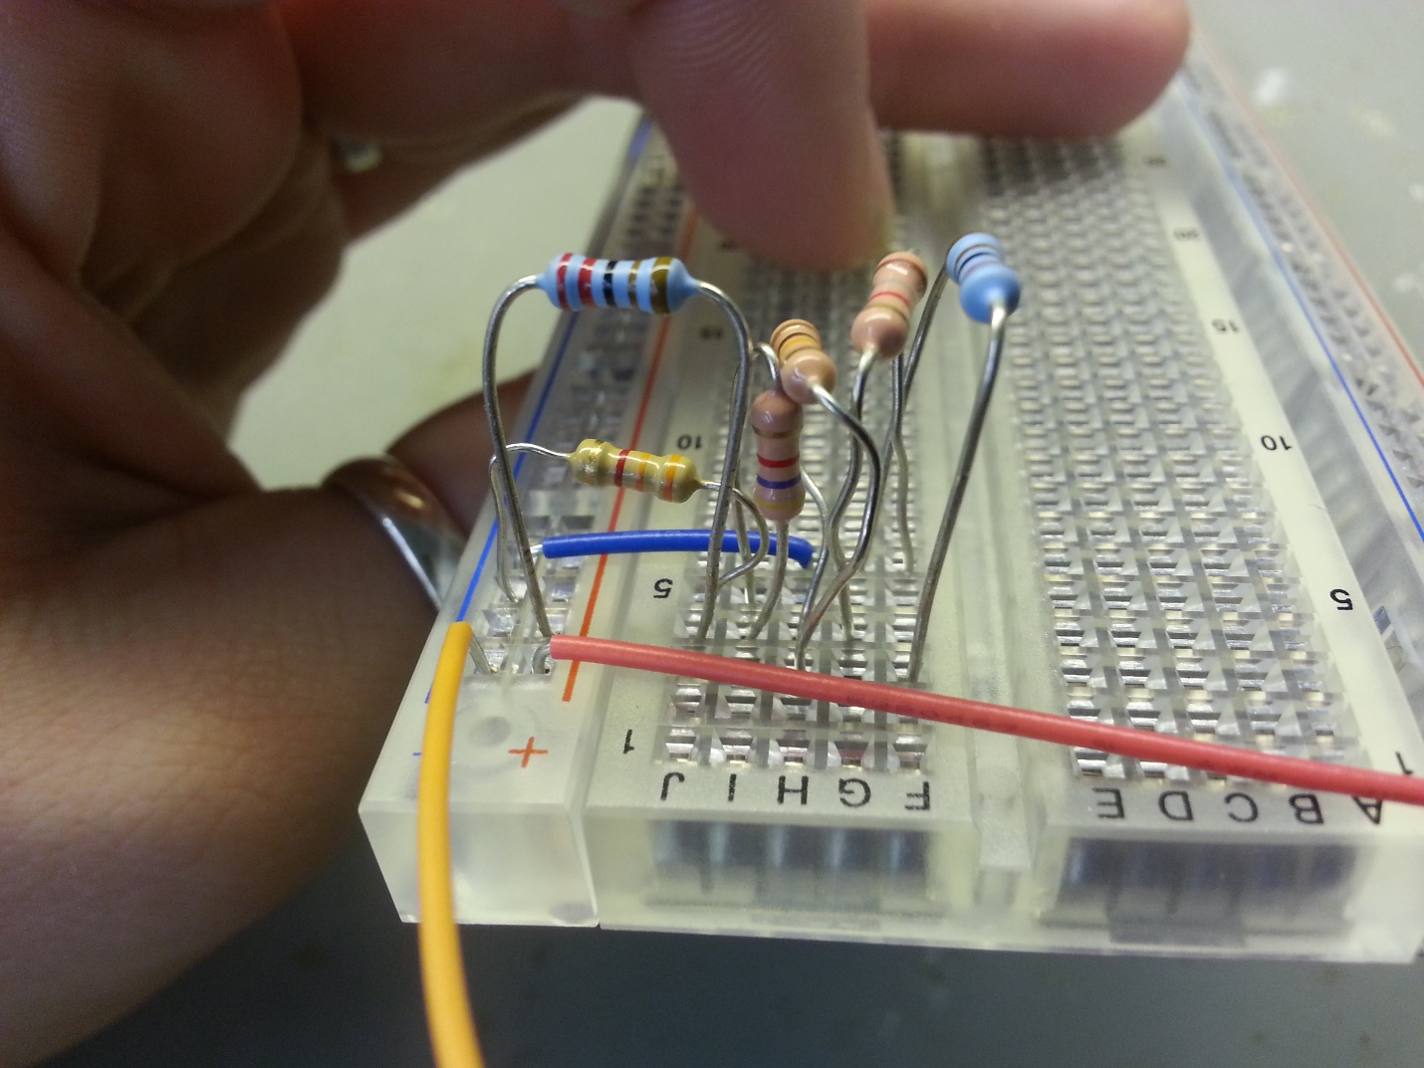

### Question 2.

Rretotal = R1 + R2345 + R6

R45 = 1.8 x 103 + 8.2 x 103 = 10 KΩ

Rretotal = R1 + R2345 + R6 = 2,2 x 103+ 2,4 x 103 + 3,3 x 103 = 7,9 KΩ

**Rretotal = 7,9 KΩ**

I1 =Itotal = ==1,26 mA

I1=I6

### 

### Question 3.

|  |  |  |
| --- | --- | --- |
|  | Calculated value | Measured value |
| Rretotal | 7.9 KΩ | 7,5 KΩ |
| I­­1 | 1.26 mA | 1,4 mA |
| I2 | 3.06 mA | 0,3 mA |
| I3 | 0.651 mA | 0,6 mA |
| I4 | 1.7 mA | 0.6 mA |
| Vout | 7.22 V | 6,02 V |

### Question 4.

### Question 5.

### Question 6.

b-c = 2,9

a-c = 10,1

### Question 7.

R45 = 2,9 + 10,1 = 13 KΩ

­

Rretotal = R1 + R2345 + R6

Rretotal = 2,2 + 2,56 + 3,3 = 8,06 KΩ

I1  = Itotal =

**I1 = 1,24 mA**

V1 = 1,24 x 10-3 * 2,2 x 103 = 2,73 V

V6 = 1,24 x 10-3 * 3,3 x 103 = 4,09 V

V2345 = 10 – 2,73 – 4,09 = 3,18 V

I4 = I5 =

**I4 = I5 = 0,25 mA**

Vout = V5 + V6

V6 = 4,09 V

V5 = I5 * R5 = 0,25 x 10-3  *2,9 x 103 = 0,73 V

**Vout = 0,73 + 4,09 = 4,82 V**

# Assignment 2.

### Question 1.

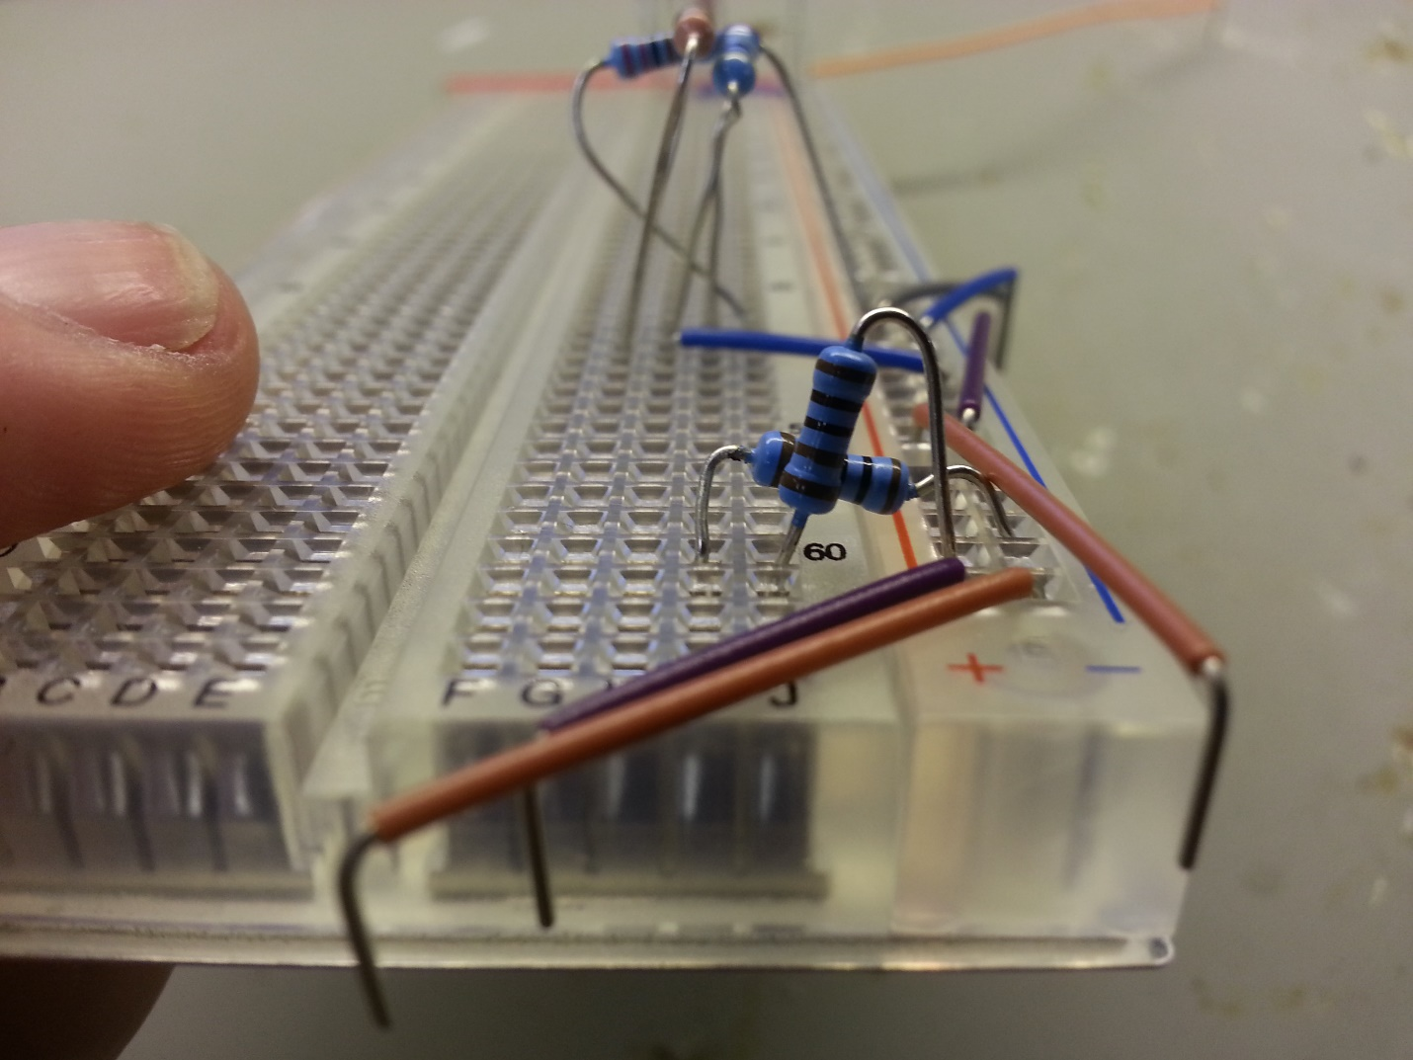

### Question 2.

100 Hz: 2 V

1 kHz : 2 V

100 kHz: 2V

### Question 3.

Vout ­= *Vin

With R = 1000 Ω and Vin  = 0,5 * 2 = 1 V. Zc can be found using the formula Zc = . With C = 100 x 10-9 and the several frequencies.

|  |  |
| --- | --- |
| f | ­Zc |
| 100 Hz | 1,6 x 104 Ω |
| 1 kHz | 1,6 x 103 Ω |
| 100 kHz | 16 Ω |

Vout ­= *Vin

Vout ­(100 Hz) = = 0,06 V

Vout ­(1 kHz) = = 0,53 V

Vout ­(100 Hz) = = 1,00 V

|  |  |  |
| --- | --- | --- |
| Frequency | Calculated value | Measured value |
| 100 Hz | 0,06 V | 0,07 V |
| 1 kHz | 0,53 V | 0,56 V |
| 100 kHz | 1,00 V | 1,02 V |

### Question 4.

With R = 1000 Ω and Vin  = 0,5 * 2 = 1 V. Zc can be found using the formula Zc = . With C = 100 x 10-9 and the several frequencies.

|  |  |
| --- | --- |
| f | ­Zc |
| 100 Hz | 1,6 x 104 Ω |
| 1 kHz | 1,6 x 103 Ω |
| 100 kHz | 16 Ω |

= 1,00V

= 0,85 V

= 1,59 x 10 -2 V

|  |  |  |
| --- | --- | --- |
| Frequency | Calculated value | Measured value |
| 100 Hz | 1,00 V | 1,02 V |
| 1 kHz | 0,85 V | 0,86 V |
| 100 kHz | 1,59 x 10-2 V | 0,02 V |

### Question 5.

The cut-off frequency is the same as the cut-off point. This is calculated as following:

F-3 ­dB =

With R = 1000 Ω

C = 100 nF = 10-7 F

F-3 dB = = 1,59 kHz

The cut-off frequency was around 1,6 kHz. Thus this seem plausible.

### Question 6.

Circuit c is a low-pass filter. You can see this when looking at the formula in question 4. Shown is that if Zc grows, Vout will have an increasing value as well. The formula for Zc shows that the impedance (and thus voltage looking at the first conclusion) increases when the frequency decreases. In conclusion: circuit c is a low-pass filter. There’s a greater output when the frequencies are lower.

# Assignment 3.

### Question 1.

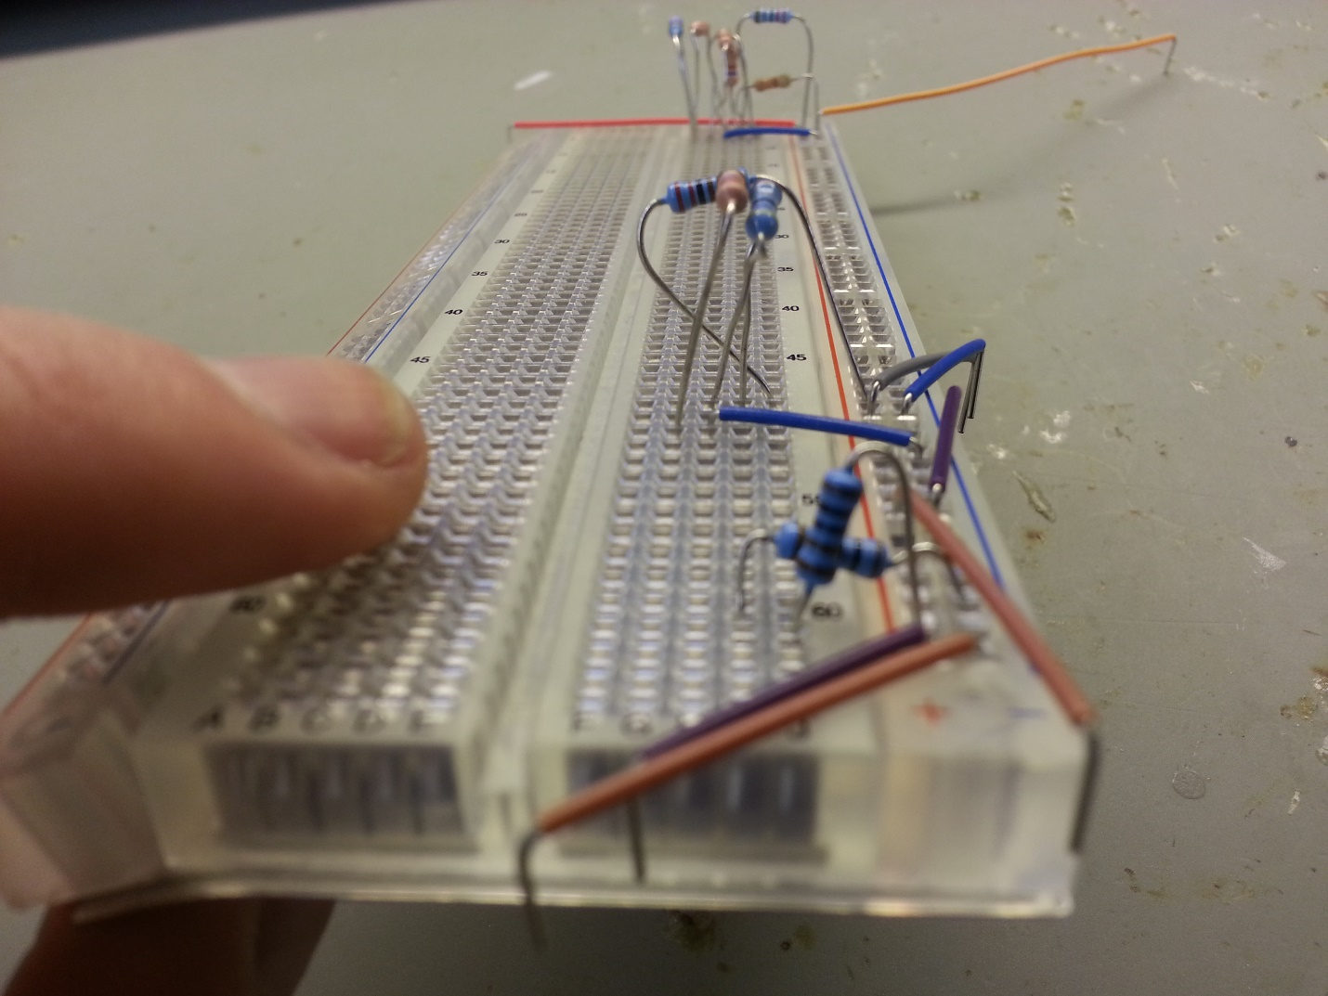

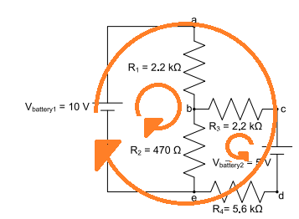

Loop 1: Va,b + Vb,e + Ve.a = 0

Loop 2: Vc,b + Vb,e + Ve,d + Vd,c = 0

Loop 3: Va,b – Vb,c  - Vc,d – Vd,e + Ve,a = 0

Loop 1:

I1 *R1 + R2 (I1 + I2 ) – Vb1 = 0

I1 * 2.2 x 103 + 470 (I1 + I2 ) – 10 = 0

I1 * 2.2 x 103 + 470 (I1 + I2 ) = 10

2670 I1 + 470 I2 = 10

I1 =

Loop 2

I2 * R3 + R2 (I2 + I1) + R4(I2) – V2= 0

I2 * 2.2 x 103 + 470 (I2 + I1) + 5.6 x 103 (I2) – 5 = 0

I2 * 2.2 x 103 + 470 (I2 + I1) + 5.6 x 103 (I2) = 5

470 I1 + 8270 I2 = 5

I1 =

Loop 3

I1 * R1  - I2 * R3  - Vb2 – I2 * R4 + Vb1 = 0

I1 * 2.2 x 103 – I2 * 2.2 x 103 – 5 – I2 * 5.6 x 103 + 10 = 0

2200 I1 – 7800 I2 = -5

I1 =

I2 = =

2670 (5-8270 I2) = 470 (10 – 470 I2)

13350 – 22080900 I2 = 4700 – 220900 I2

-21860000 I2= 8650

**I2 = 0,396 mA**

I1 =

=

**I1=3,68 mA**

### Question 3.

The voltage drops:

V1 = R1 * I1 = 2.2 x 103 * 3,68 x 10-3 = 8,096 V

V2 = R2 (I1 + I2 ) = 470 (3,68 x 10-3 + 0,396 x 10-3) = 1,915 V

V3 = R3  * I2  = 2.2 x 103 * 0,396 x 10-3 = 0,871 V

V4 = Vbattery 2 – V2 – V3 = 5 – 1.915 – 0,871 = 2,214 V

|  |  |  |
| --- | --- | --- |
| Voltage drops | Calculated value | Measured value |
| ­V1 | 8,096 | 8,14 |
| V2 | 1,915 | 1,92 |
| V3 | 0,871 | 0,88 |
| V4 | 2,21 | 2,25 |

### Question 4.

The calculated voltage drops are comparable to the measured voltage drops. Thus the calculations are done right.

**Assignment 4**

|  |  |
| --- | --- |
| Vd (V) | Id (A) |
| 0 | 0 |
| 0.2 | 0 |
| 0.4 | 0 |
| 0.6 | 0 |
| 0.8 | 0 |
| 1.0 | 0 |
| 1.2 | 0 |
| 1.4 | 0 |
| 1.6 | 0.01 |
| 1.8 | 0.01 |
| 2.0 | 0.01 |
| 2.2 | 0.01 |
| 2.4 | 0.01 |
| 2.6 | 0.01 |
| 2.8 | 0.01 |
| 3.0 | 0.01 |
| 3.2 | 0.01 |
| 3.4 | 0.01 |
| 3.6 | 0.01 |
| 3.8 | 0.01 |
| 4.0 | 0.02 |
| 4.1 | 0.03 |
| 4.2 | 0.07 |
| 4.3 | 0.10 |
| 4.4 | 0.16 |
| 4.5 | 0.24 |
| 4.6 | 0.33 |
| 4.7 | 0.37 |
| 4.8 | 0.41 |

‘Knee’ voltage

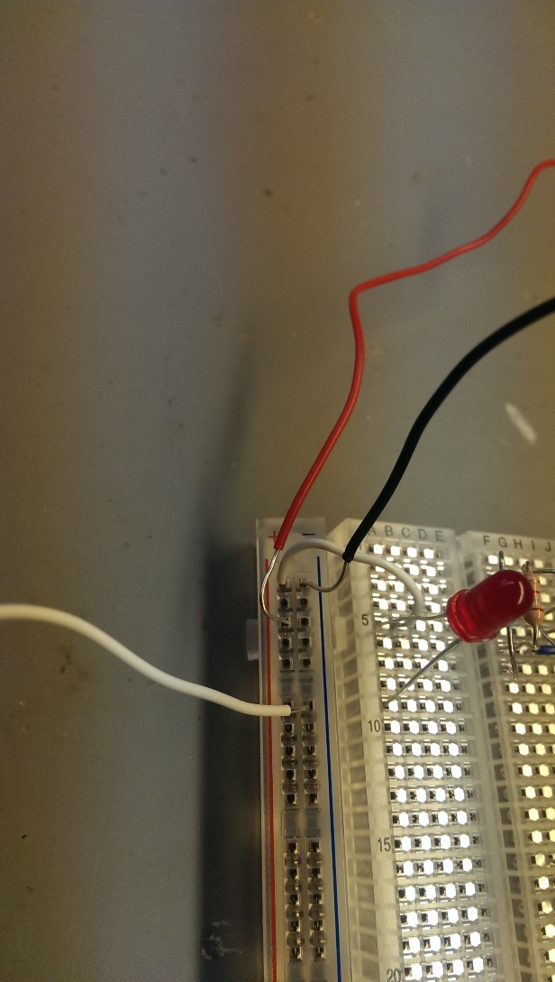We detected the knee voltage by looking at the graph. Hereby we detected the point where the graph increases rapidly. In our case the knee voltage is 3.8 V.

# Assignment 5

|  |  |  |  |
| --- | --- | --- | --- |
| Rb (KΩ) | Ic (mA) | Vce (V) | Vbe(V) |
| 100 | 21.5 | 2.30 | 0.70 |
| 10 | 36.5 | 0.36 | 0.79 |
| 4 | 40.2 | 0.15 | 0.81 |
| 2 | 40.6 | 0.10 | 0.82 |
| 1 | 40.7 | 0.06 | 0.83 |
| 0.47 | 40.8 | 0.05 | 0.86 |

Saturation is reached somewhere between 10 KΩ and 4 KΩ, here Vce becomes small and Vbe becomes almost constant. We did not really know what to expect, since this is our first time doing this.

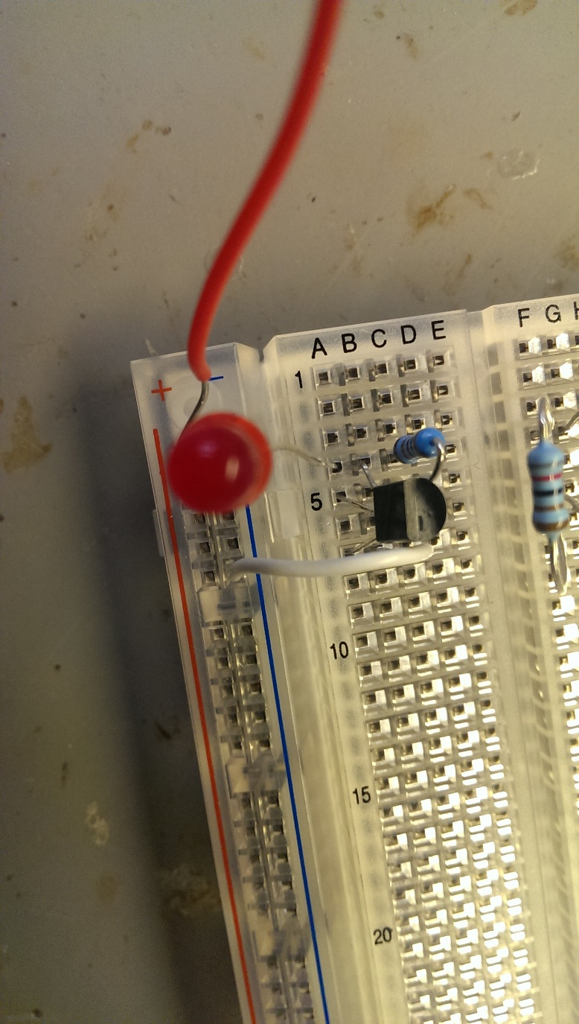

# Assignment 6

### Question 1

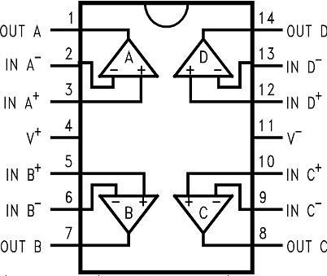

### Question 2

Calculations:

Vmax = 10 V

Vmin = 0 V

R1 = 10000 Ω

R2 = 10000 Ω

R3 = 100000 Ω

Vout = 10 V

Vin+ =

Vmin = 0 V

Vin+ =

### Question 3.

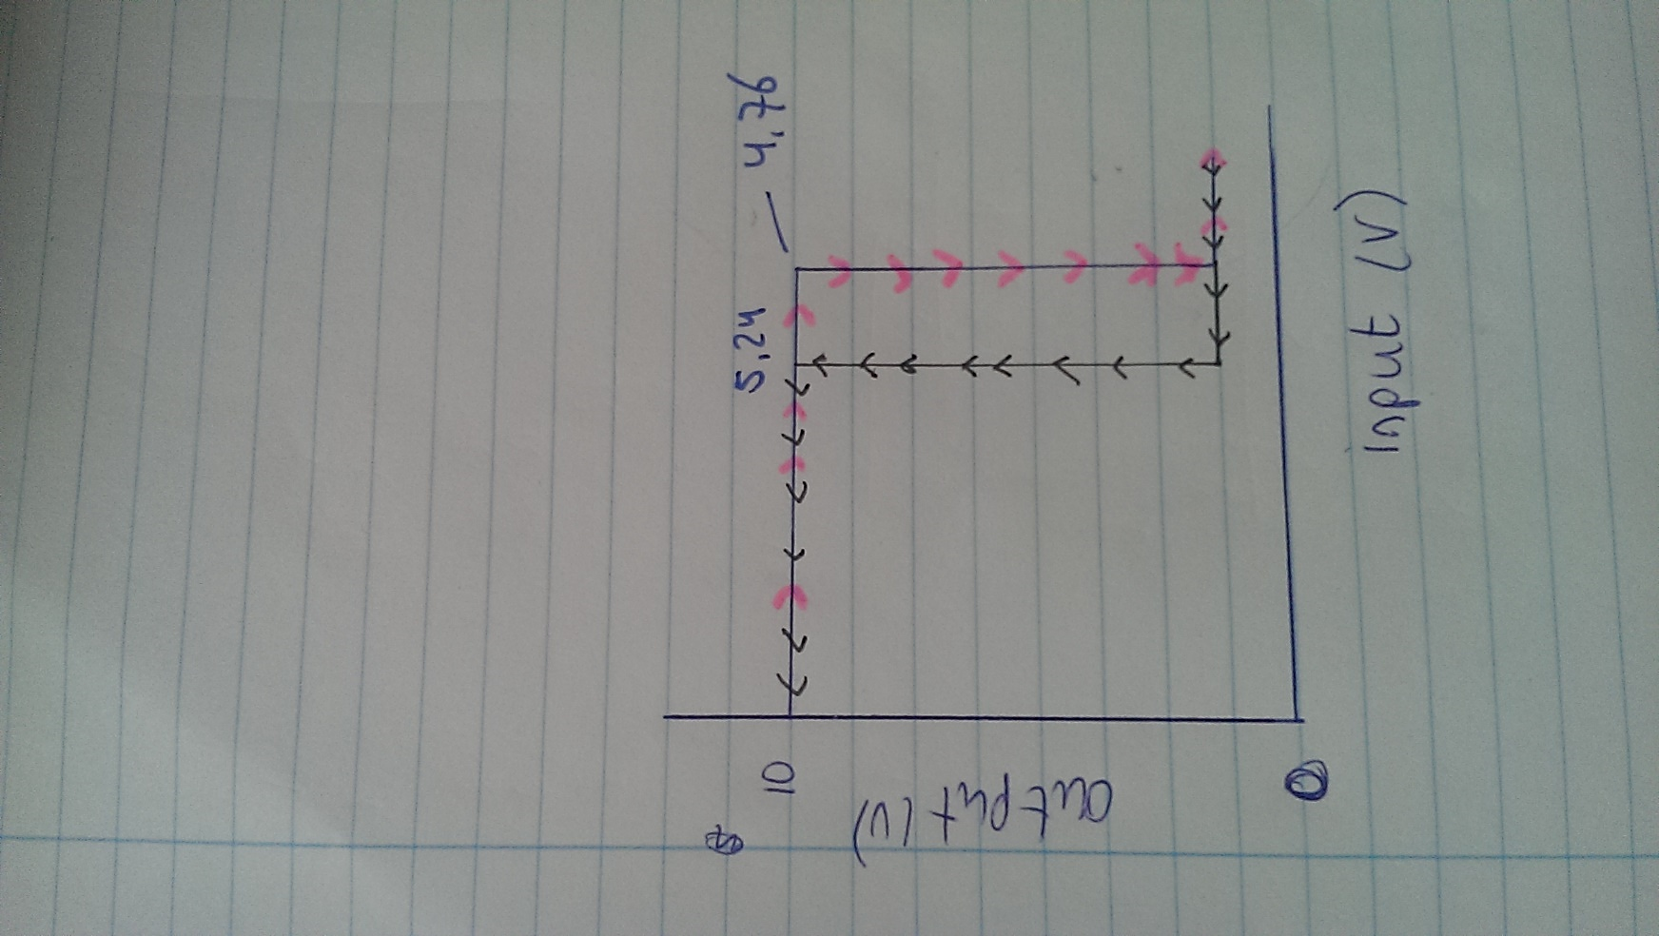

# Final Assignment

In this assignment we had to build our own central heating system. The several assignments that we made before making this final assignment prepared us in order to be able to make this central heating system. This ‘ultimate challenge’ gave us the opportunity to showcase all the new things we have learned.

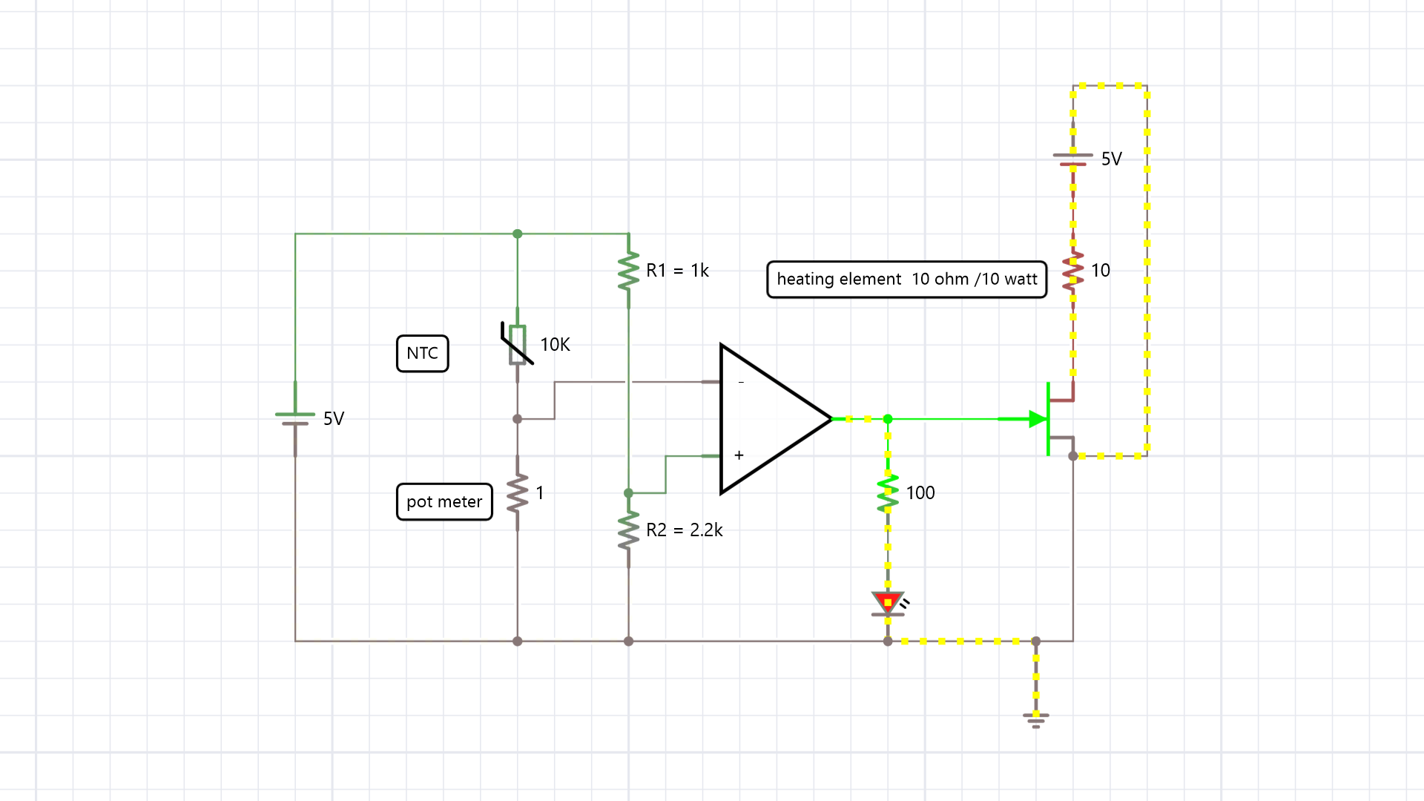

2.2K

Vc

5.74 Kohm

Vb

X

Calculations:

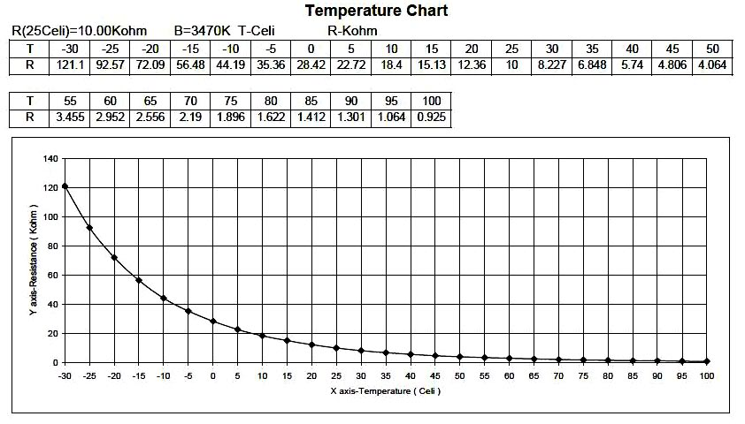

Rvalue we need is 5.74 Kohm, according to the graph.

We cannot quickly change the temperature inside the box, because air cannot conduct temperature easy. Therefore the system needs time to lose its heat and to gain heat again.

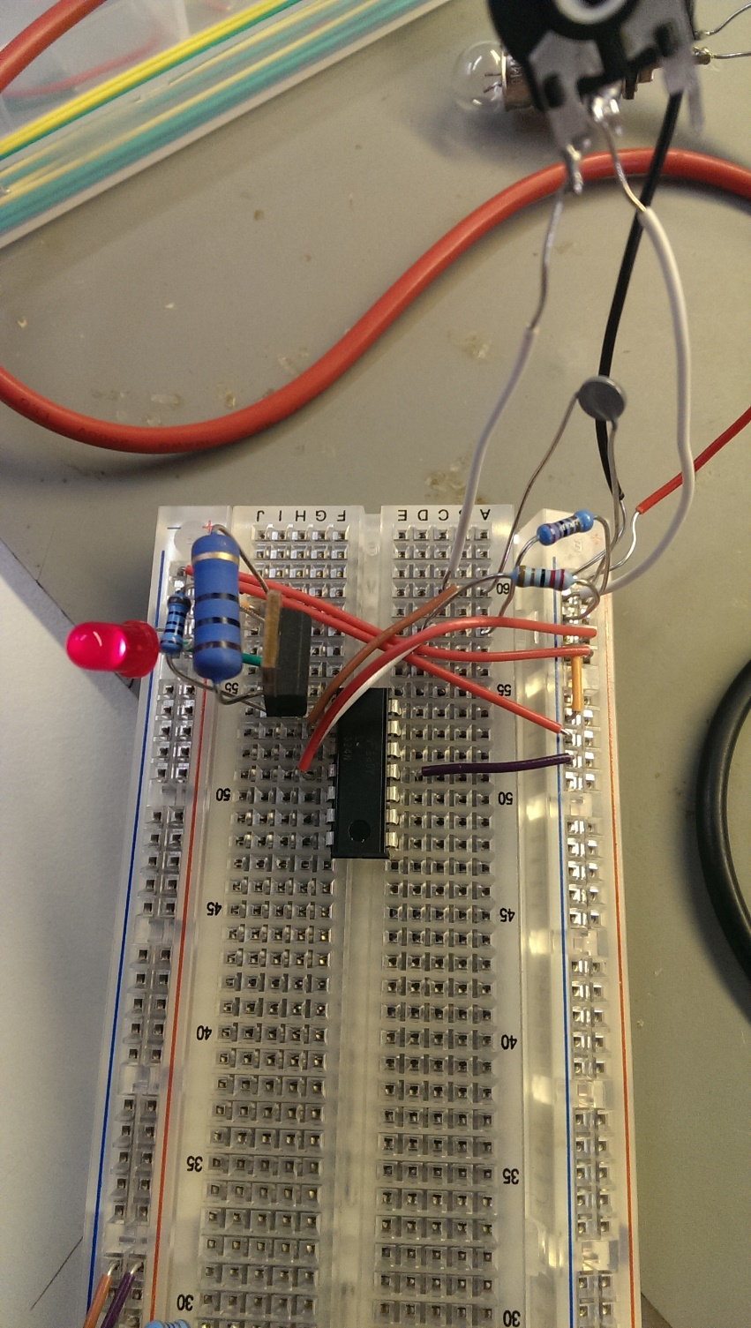

# Reflection Lisa Stavenuiter

First of all I chose this assignment because I had no experience with electronics at all. I was eager to learn about electronics and knew I could learn a lot during this assignment. During the first weeks I noticed that I developed a certain interest in electronics, although the assignments and lectures were not always easy. I tried to push myself because being able to work with electronics is, in my opinion, an essential part of being a good designer. Although my interest in electronics was growing, the assignments in the first weeks were not that exciting, and due to a significant amount of other deadlines and homework we postponed a lot of our work. Reflecting on this, I can say this was not a smart thing to do. A better thing to do next time would be keeping up with the assignments and make an arrangement with my partner to work on the assignment on a set time each week. However the ‘final’ assignment was a really good assignment to end this quartile with. Making the central heating system made me realize I did gain a certain level of knowledge about electronics. And making this central heating system gave me a level of confidence about being able to integrate electronics whenever I need to. When we finally succeeded in building it, and each burning a finger, we were super excited to start with our next project. In the mini project you can clearly see what kind of designer I want to become. The musical enlightenment, a project which allows people to (learn how to) play piano in a fun and easy way. I believe in designing useful, fun products that help and motivate people. Building the Arduino was not that hard since I worked with the Arduino before in my Smart Health project, however I did not know how to create a tone with the Arduino. So I did need some help with that. I discovered that during the mini project we used the multimeter a lot, this is an easy way to debug a circuit. In the end we were, again, very proud of the result of our project that we realized in only one week. In conclusion: when starting this assignment I never thought I would learn this much about electronics in such a short time. I am confident to start working on the electronics in my next project. I believe this was a useful assignment since I learned a lot. Besides learning about electronics I also learned the importance of planning.

# Reflection Marije Baars

When I chose for the assignment Creative Electronics I was expecting to learn how to build an electrical circuit and how to use this knowledge in further on prototypes. I thought this would mostly entail basic knowledge of the electrical elements and how to use it properly.

Throughout the assignment the theoretical information is handed to you and is up to you to do something with it. Throughout the practical assignments I first discovered the basics of electronics and how to use the different components. Because the practical assignments level challenges you to use and expand your knowledge more, it really forced be to learn allot by myself through the assignments.

Because of the assignment I can use the different electrical components and know its names and functions. I still find it hard to fully make an electrical circuit, but now I can understand one when I see it. I am able to find the fault within the system, by measuring the voltage and doing calculations. Especially the usage of a multi-meter allowed me to directly get feedback on the system I build and continuously seeing where our fault lied or I if it did worked properly.

I know that I still have allot to learn within the electronics world, but with this knowledge I gained from the assignment I am planning to use in my upcoming project. I am not only planning on trying to make the prototypes myself more, but also understanding the electrical part of the prototypes other people make and hereby learning more about it myself.